**OBJECT ORIENTED PROGRAMMING**

**LAB PRACTICAL 1**

**Received Date : 20 March 2021**

**Submission Date : 20 March 2021**

**Weightage : 20%**

**Semester : SEPT- 2021**

**Instruction to students:**

* This is GROUP assignment.
* Complete this cover sheet and attach it to your assignment (first page).

|  |  |  |
| --- | --- | --- |
| **Student declaration:** | | |
| ***I declare that:***   * ***This assignment is my own work*** * ***I understand what is meant by plagiarism*** * ***My lecturer has the right to deduct my marks in the case of:*** * ***Late submission***   ***Any plagiarism found in my assignment.*** | | |
| **Name** | **Student ID** | **Picture** |
| NUR WAZILA BINTI WAHID | 2022019070050 |  |
| MUHAMMAD AMSYAR BIN ABDUL MALEK | 2022020070028 |  |
| INDRA BIN ISMAN | 2022019070041 |  |

|  |  |
| --- | --- |
| **MARKS:** | **Total** |
|  |

**ASSIGNMENT 2**

**CHAPTER /TOPIC: OBJECT ORIENTATION PROGRAMMING**

**INSTRUCTION:**

1. Mode: Group
2. Submission in the form of **Hard Copy** and a **Soft Copy** to be submitted through **Google Classroom** and **eklas**.
3. Date of Submission: **March. 20, 2021 (Saturday)**

**CHAPTER:**

Chapter 2: Object Orientation Programming

**WEIGHTAGE:** **20%**

20% - Report (Group) – 50 marks

**PROGRAM OUTCOME(S):**

PO4: Values, attributes & professionalism (Assignments, Group project)  
PO6:  Problem Solving and Scientific Skills (Lecture, Practical, Assignments, Group Project)

**Course outcome (s):**

At the end of the course, students will be able to:

CO2 demonstrate the object-oriented concepts of class, object creation through constructors, inheritance, and modifiers based on actual examples.

CO3 implement arrays, strings and suitable exception handlers to manage Java programs that require these components.

Answer for Question 1:

Q_01.java

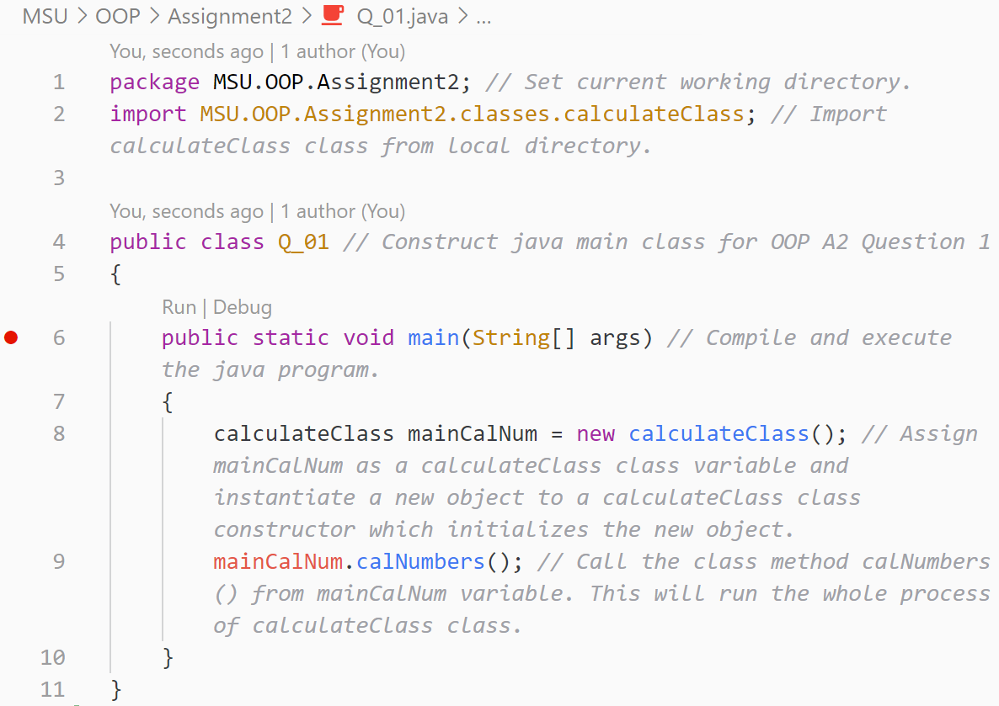

Answer for Question 1(continue):

calculateClass.java

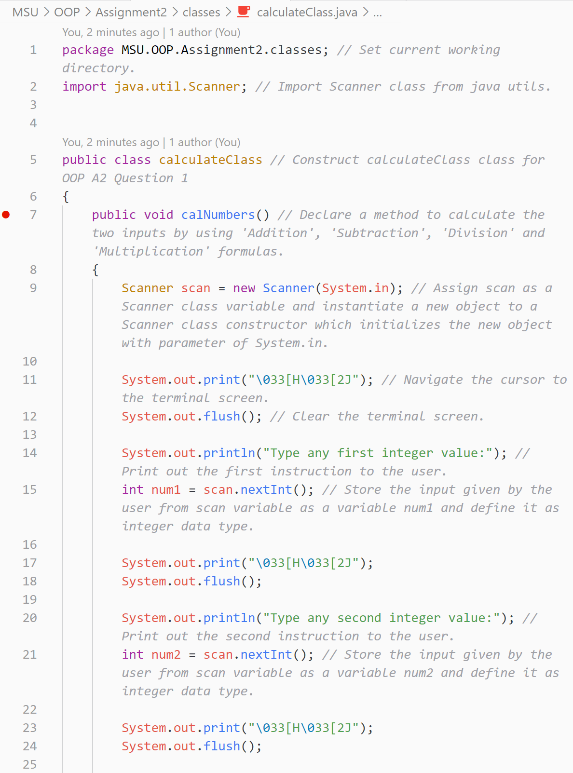

Answer for Question 1(continue):

calculateClass.java

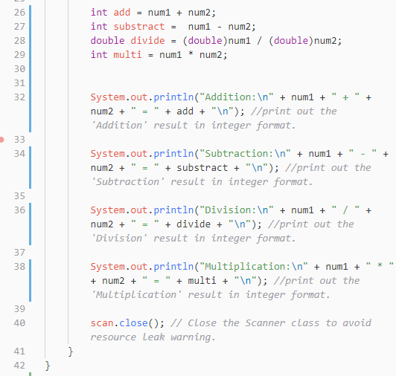

Answer for Question 2:

Q_02.java

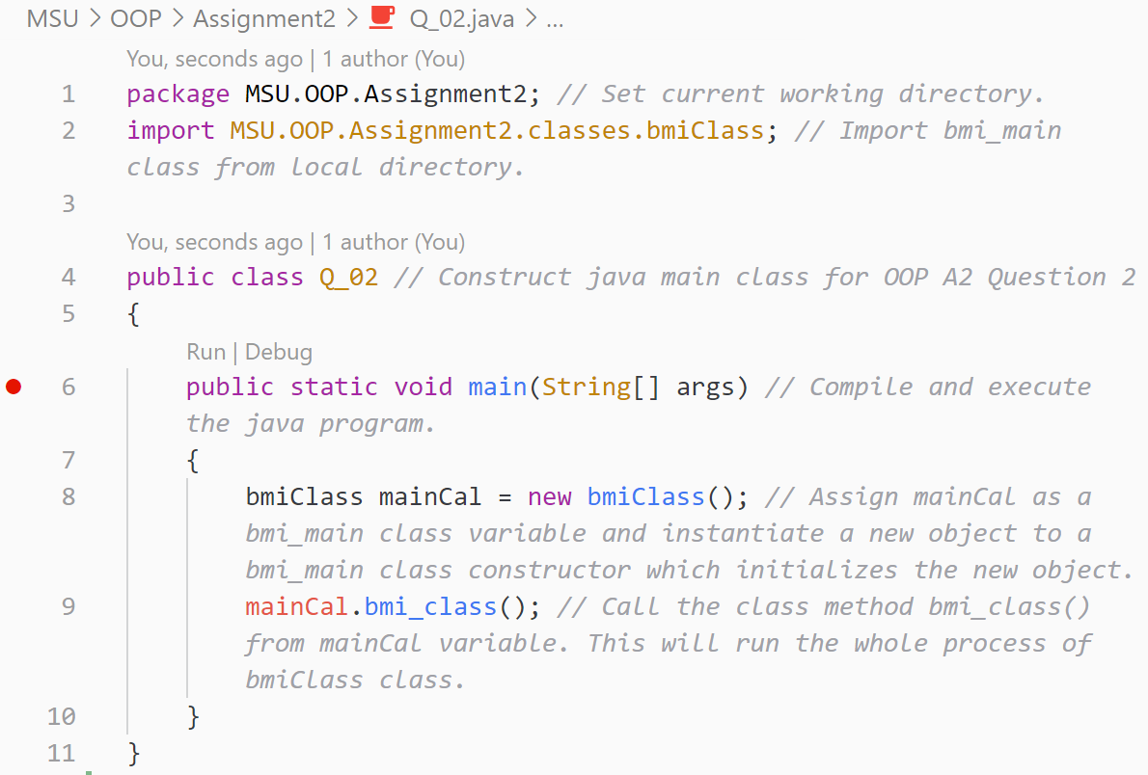

Answer for Question 2(continue):

bmiClass.java

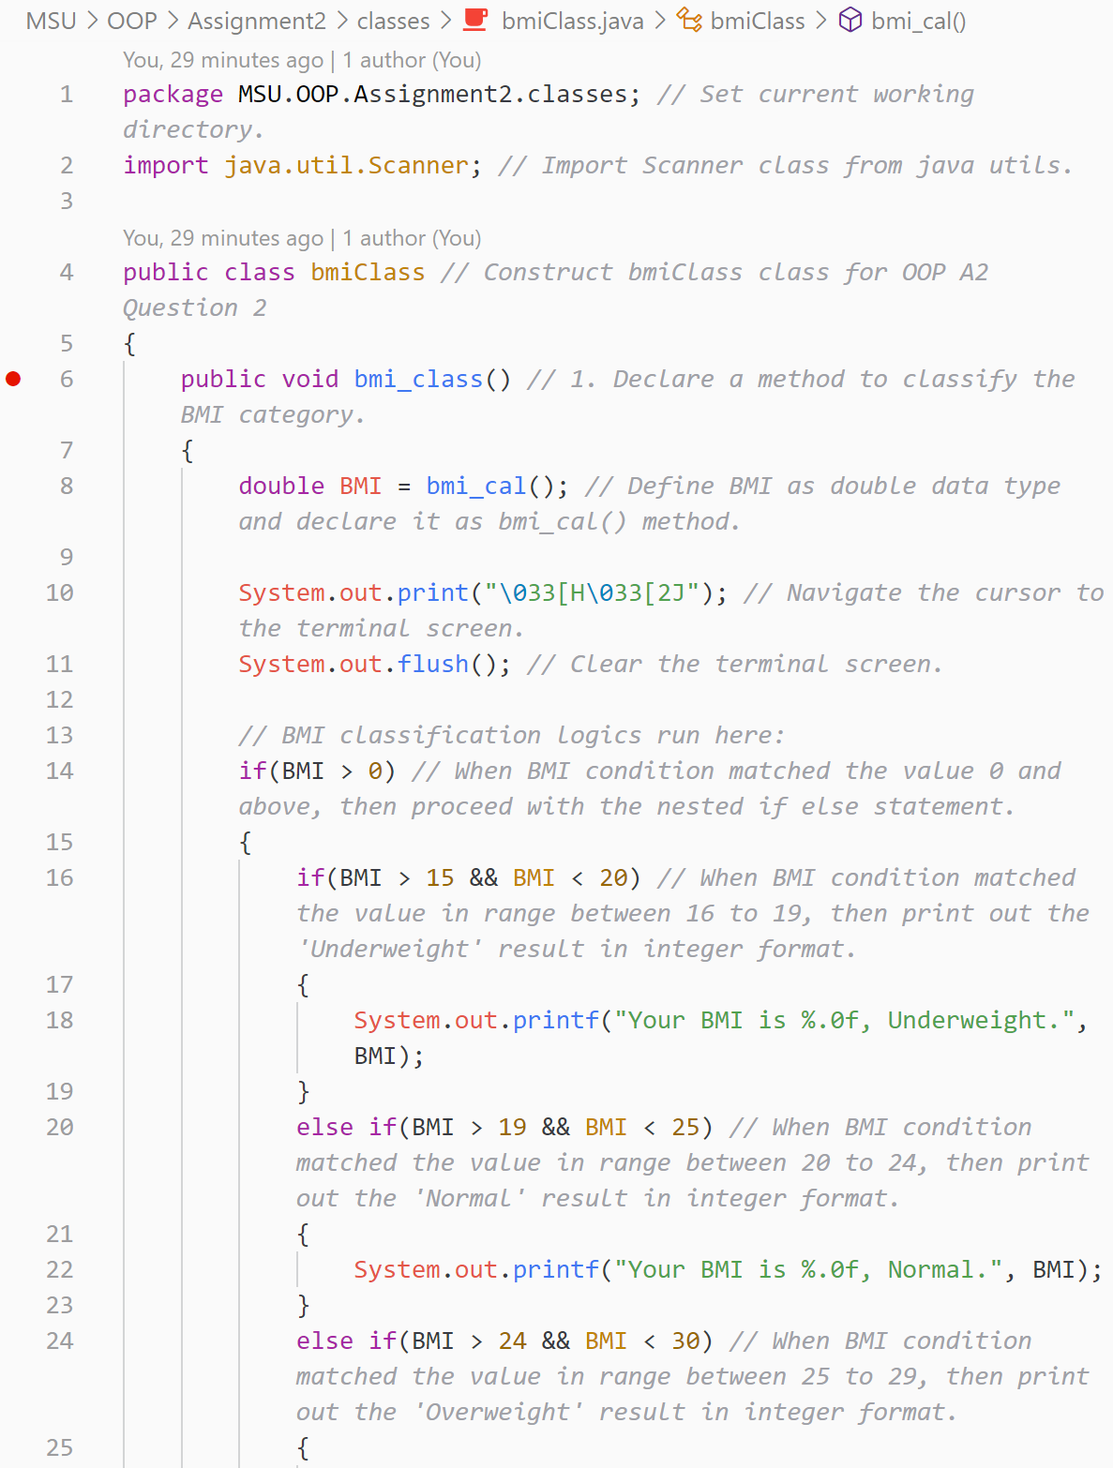

Answer for Question 2(continue):

bmiClass.java

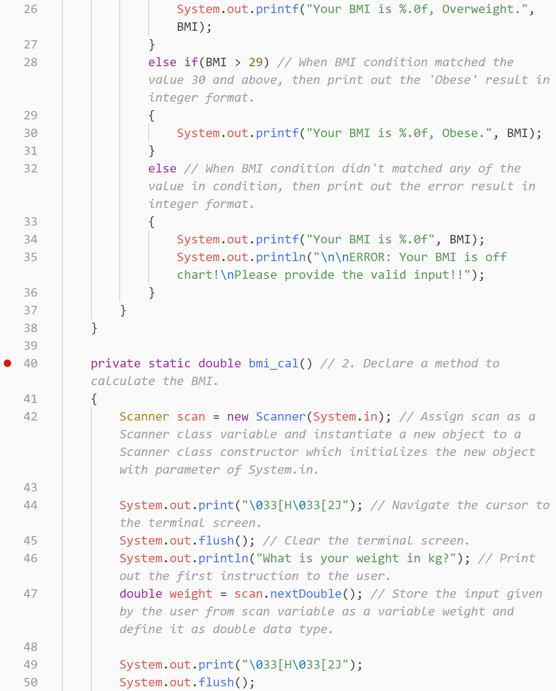

Answer for Question 2(continue):

bmiClass.java

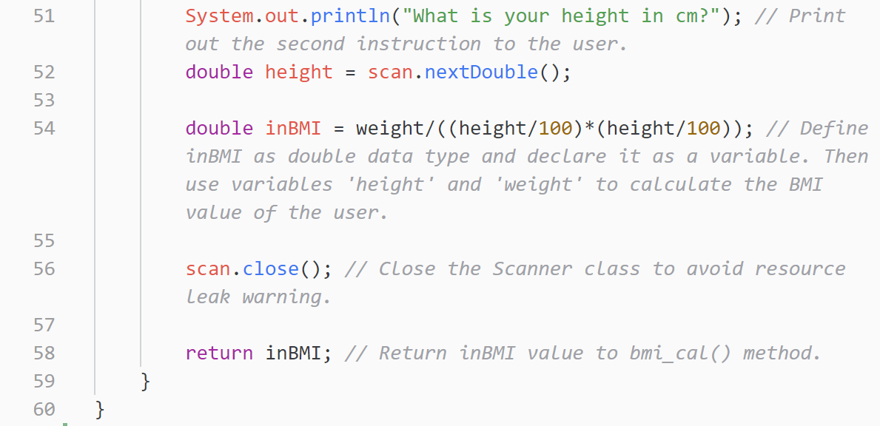

Answer for Question 3:

Q_03.java

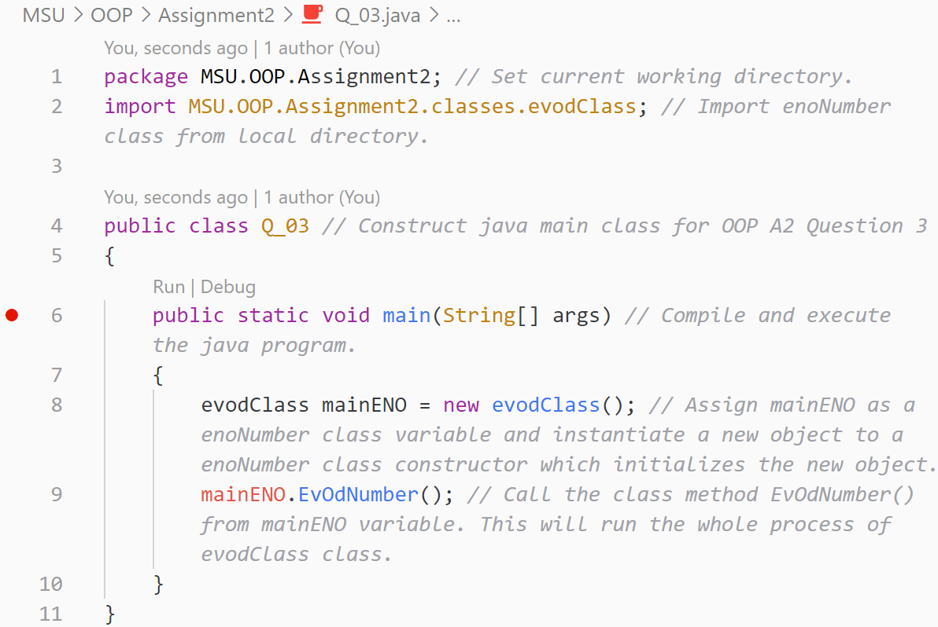

Answer for Question 3(continue):

evodClass.java

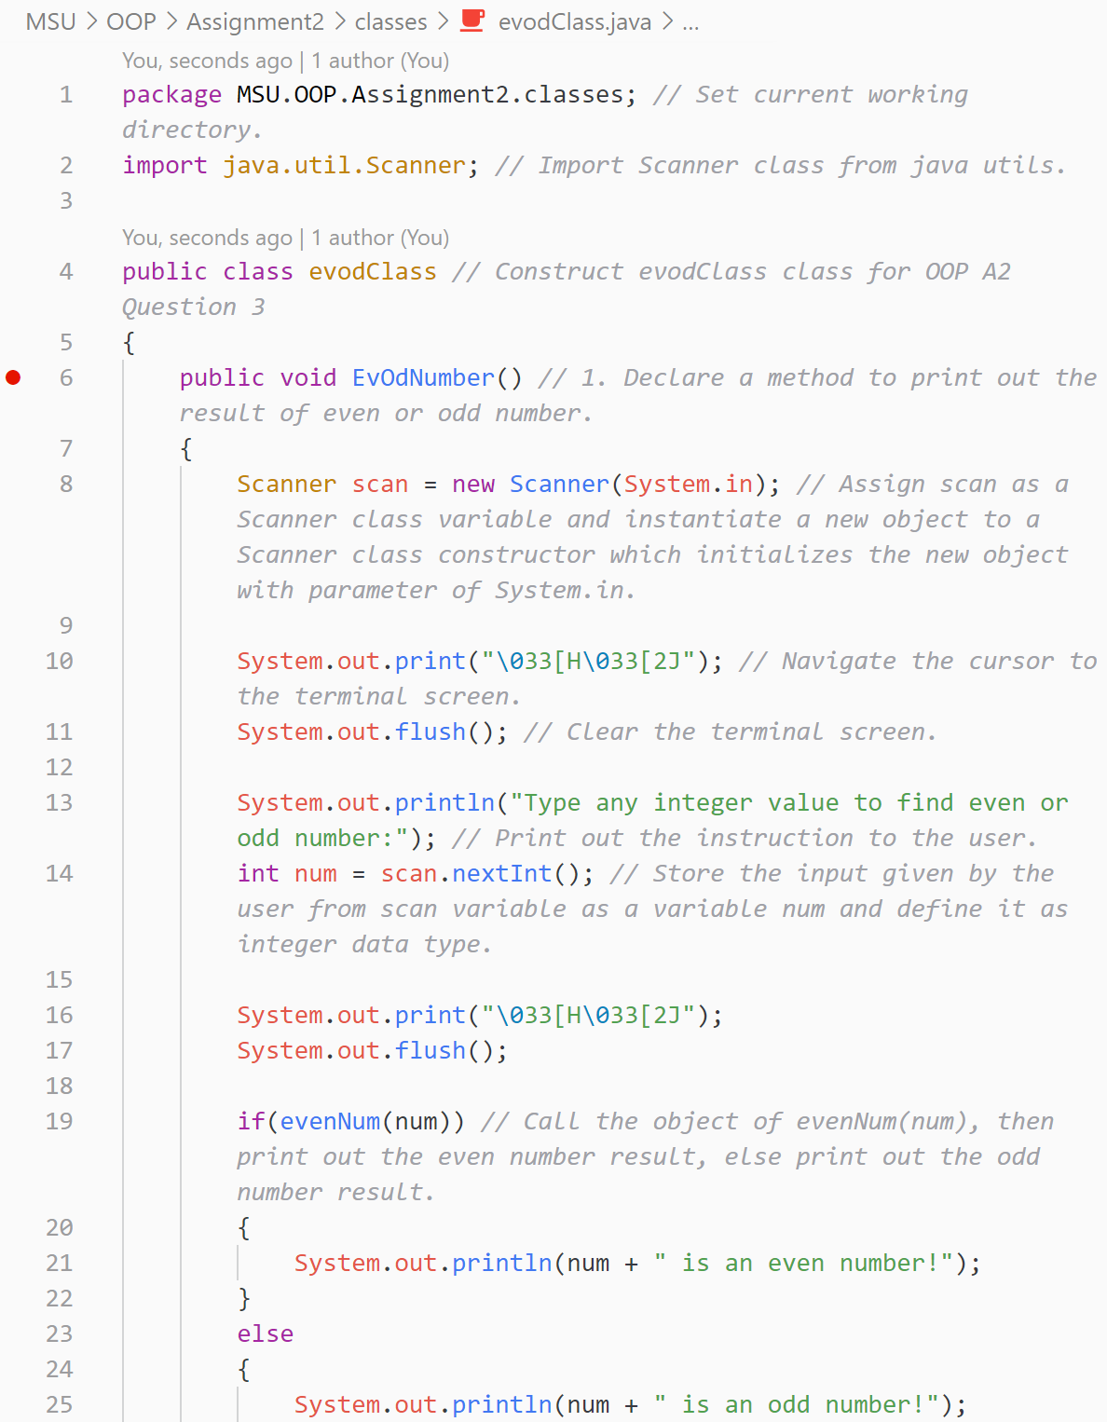

Answer for Question 3(continue):

evodClass.java

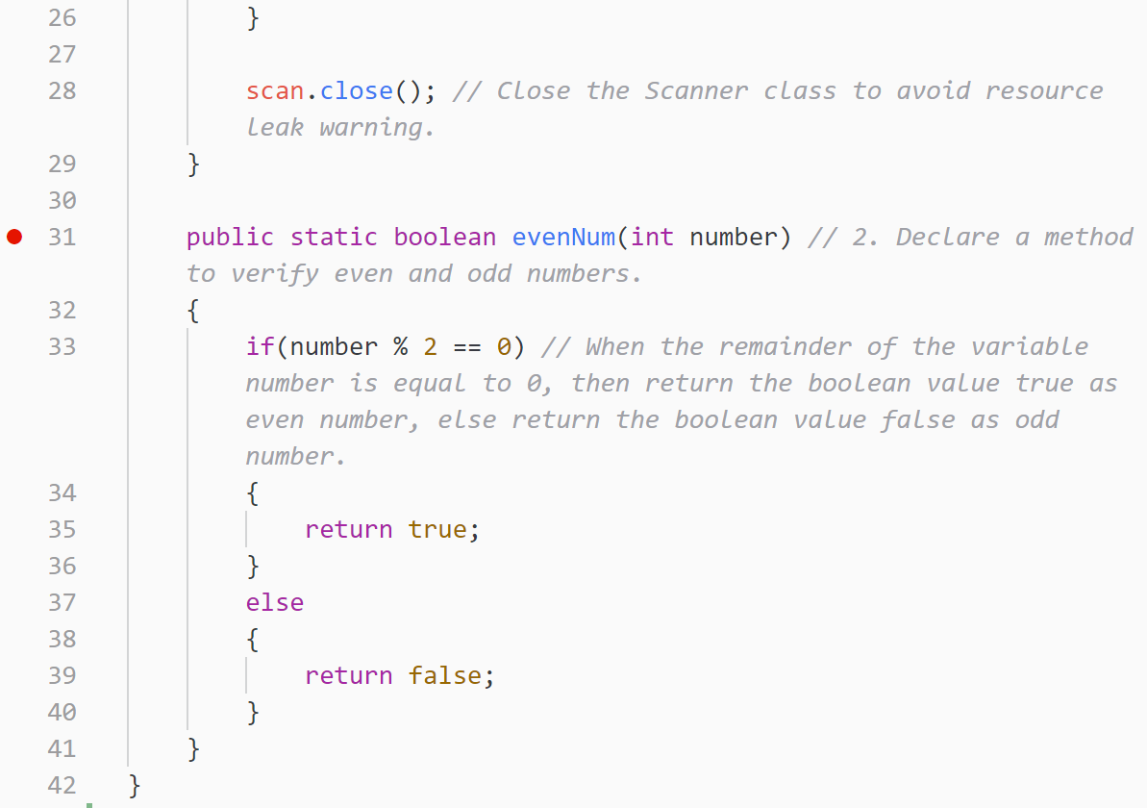

Answer for Question 4:

Q_04.java

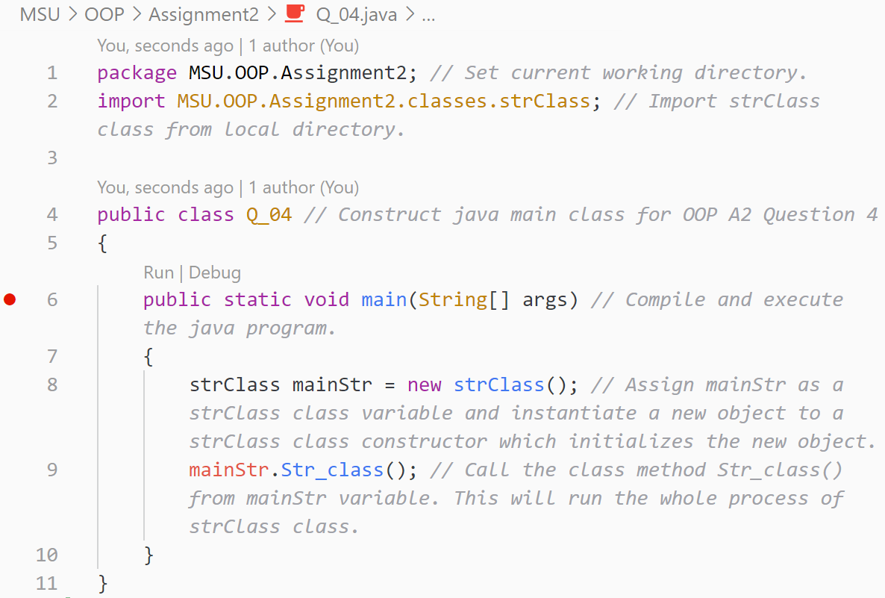

Answer for Question 4(continue):

strClass.java

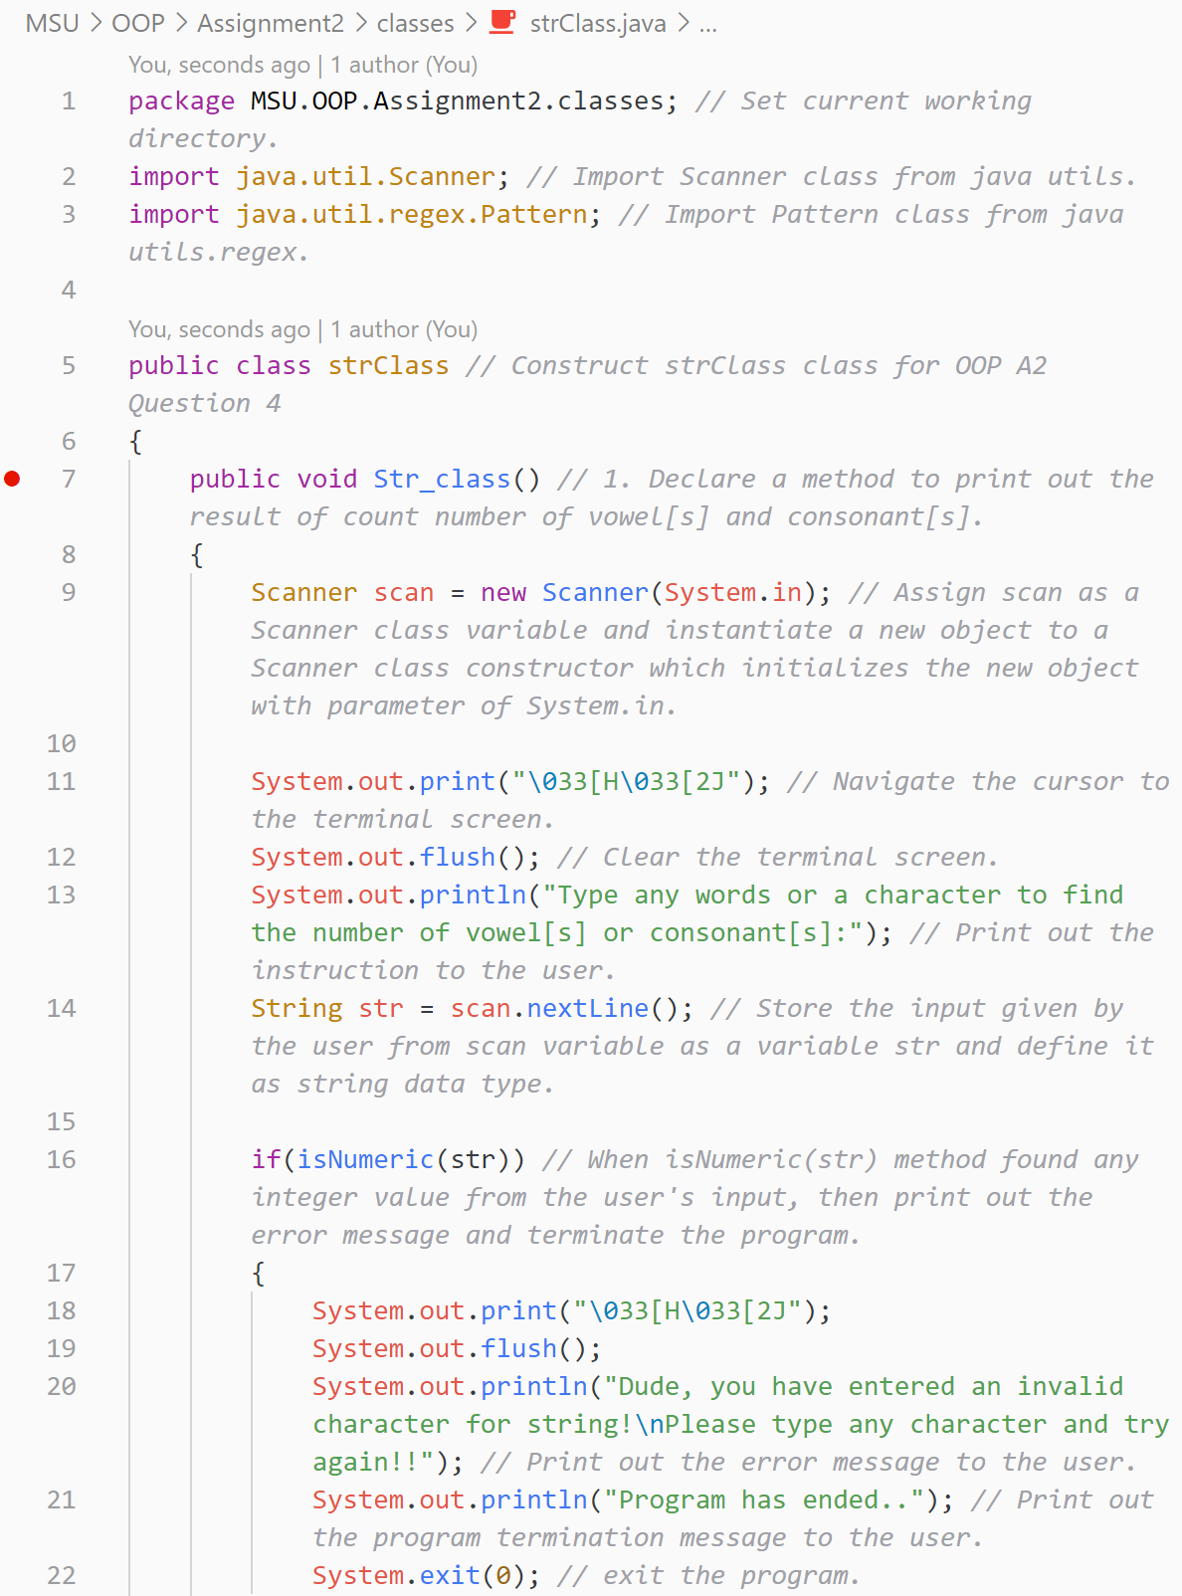

Answer for Question 4(continue):

strClass.java

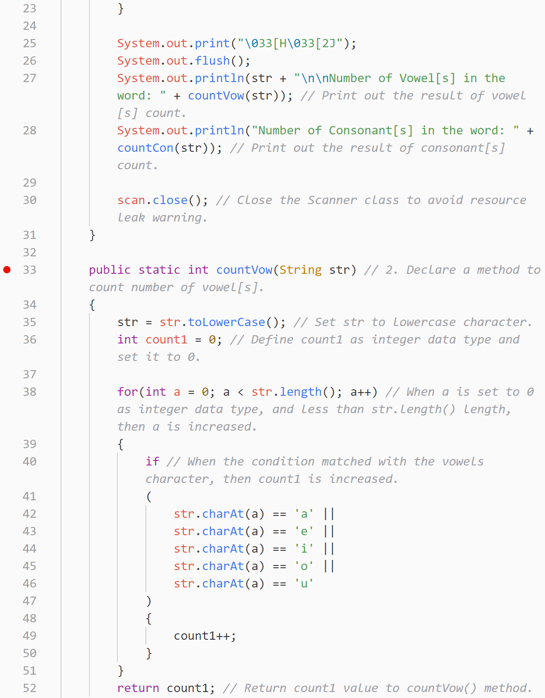

Answer for Question 4(continue):

strClass.java

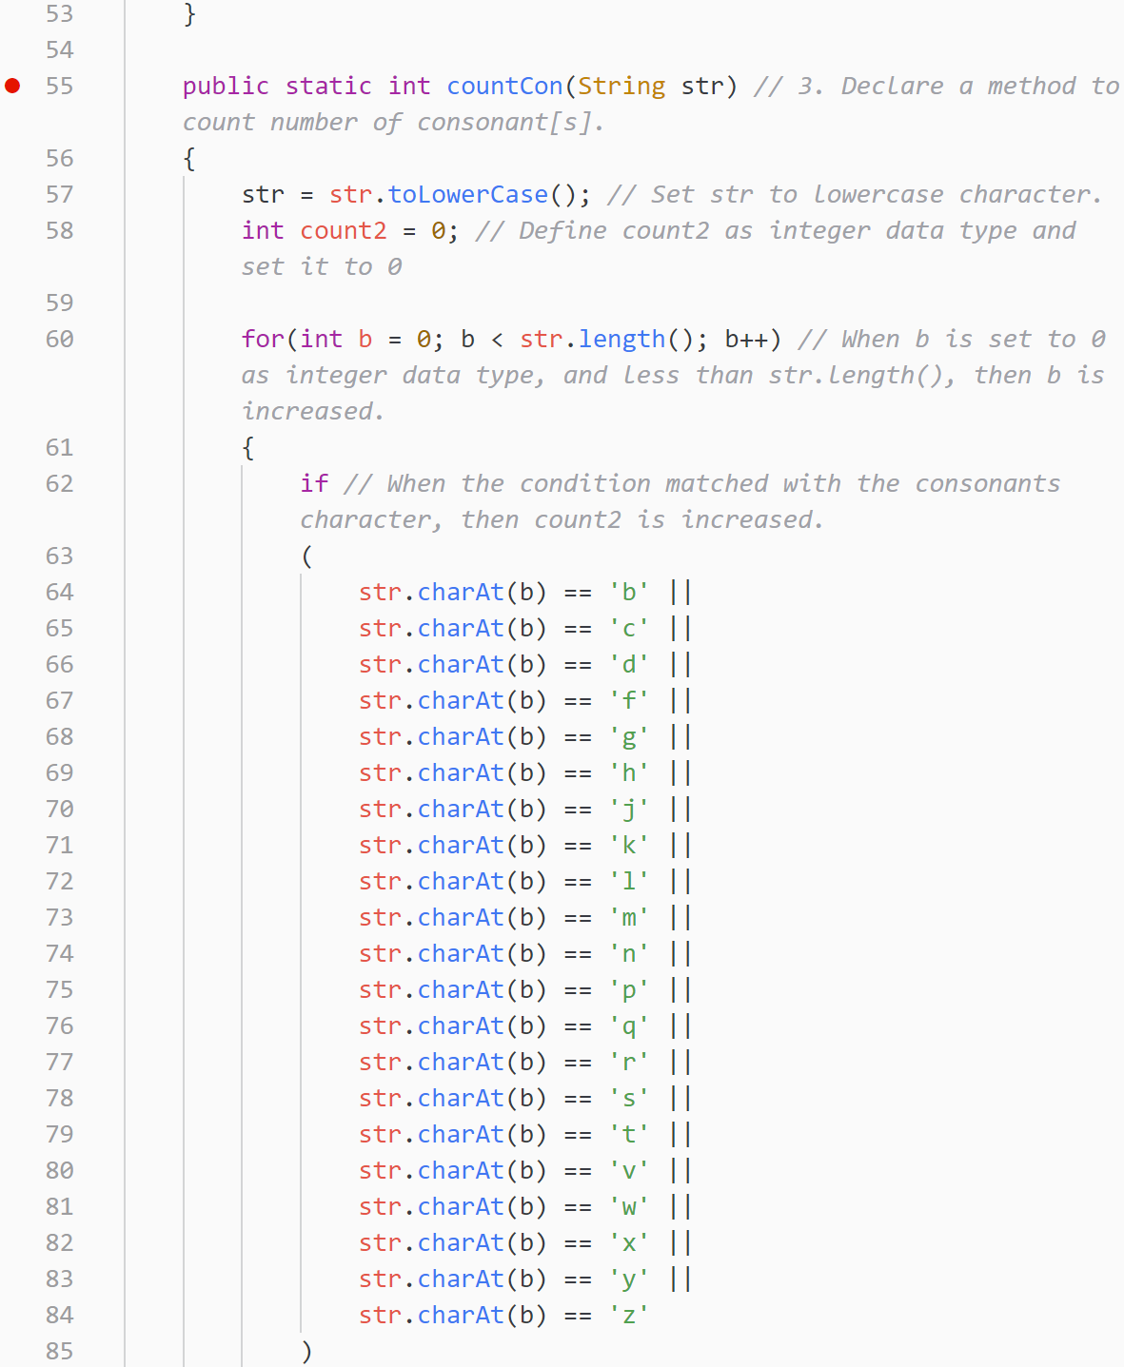

Answer for Question 4(continue):

strClass.java

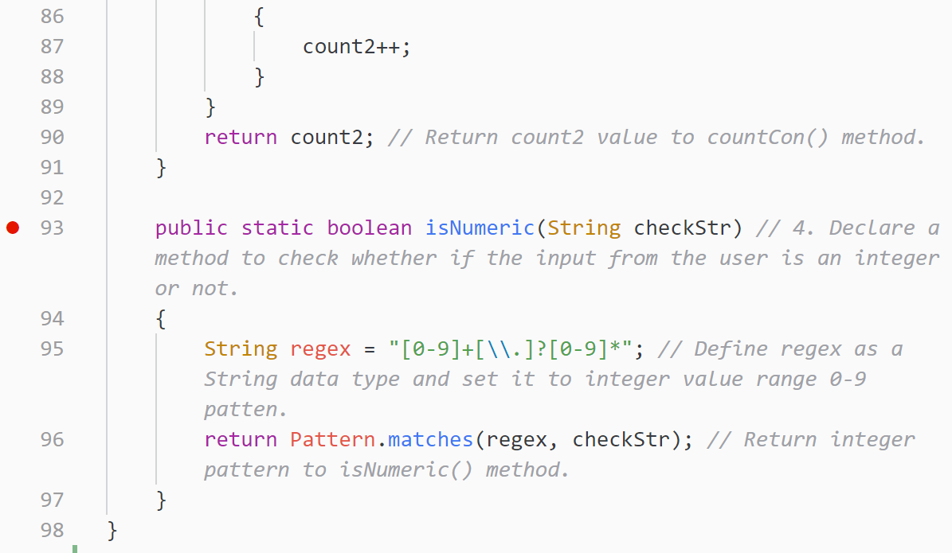

Answer for Question 5:

Q_05.java

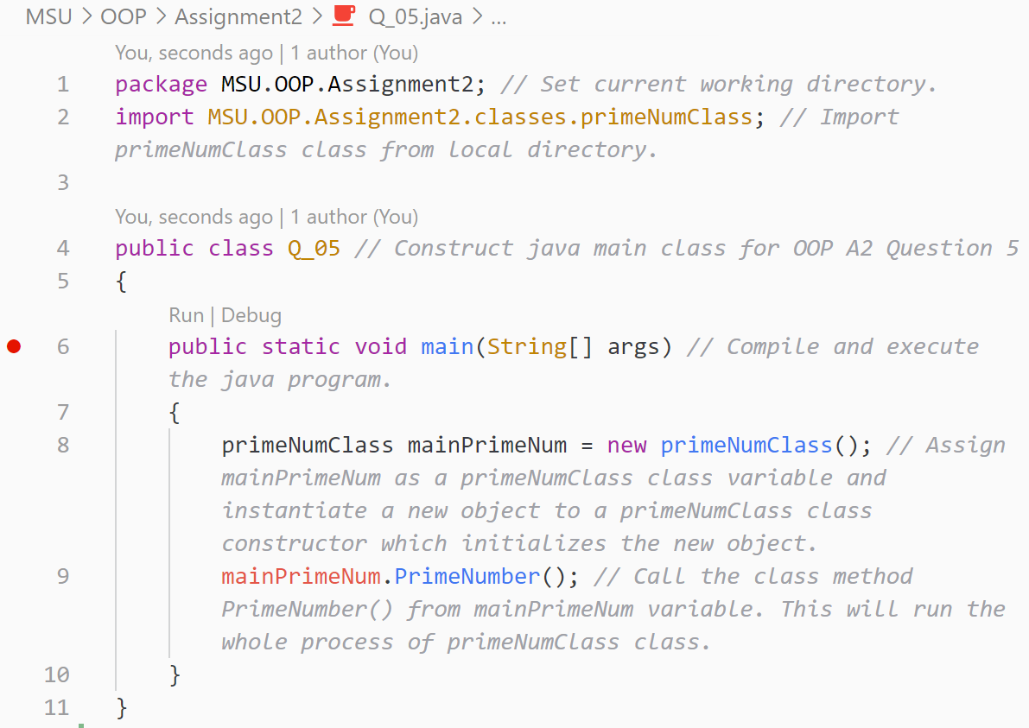

Answer for Question 5(continue):

primeNumClass.java

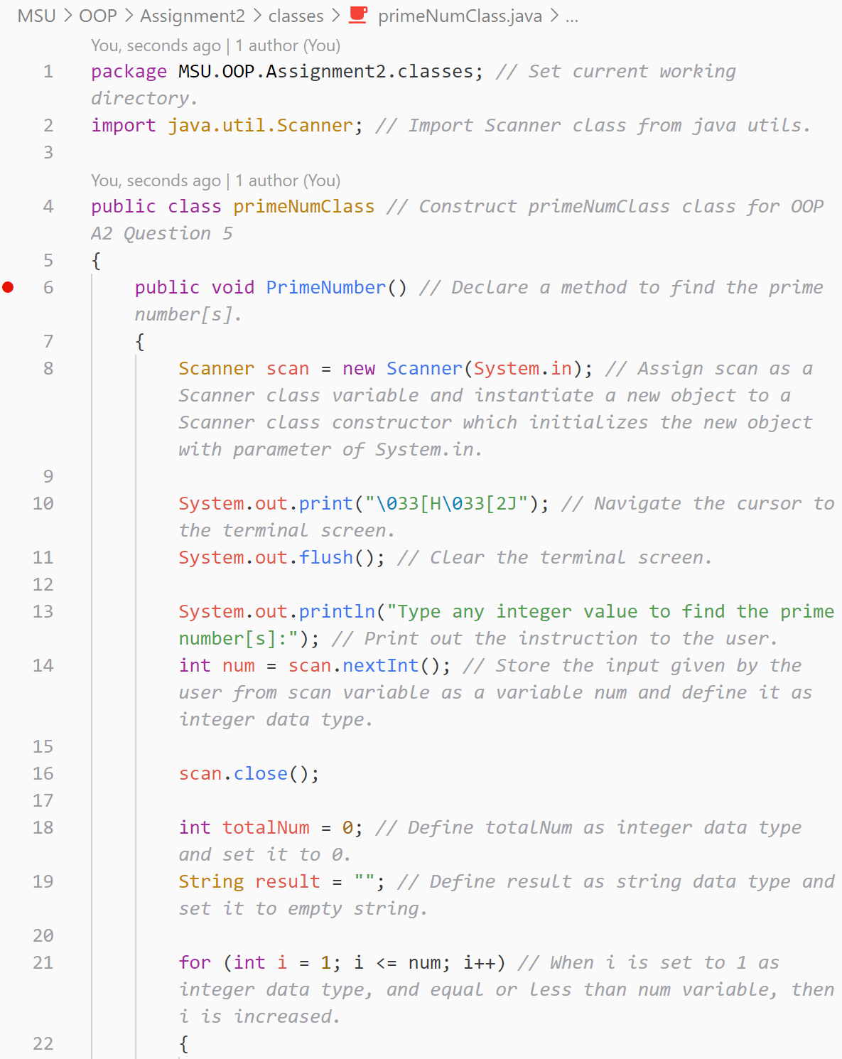

Answer for Question 5(continue):

primeNumClass.java

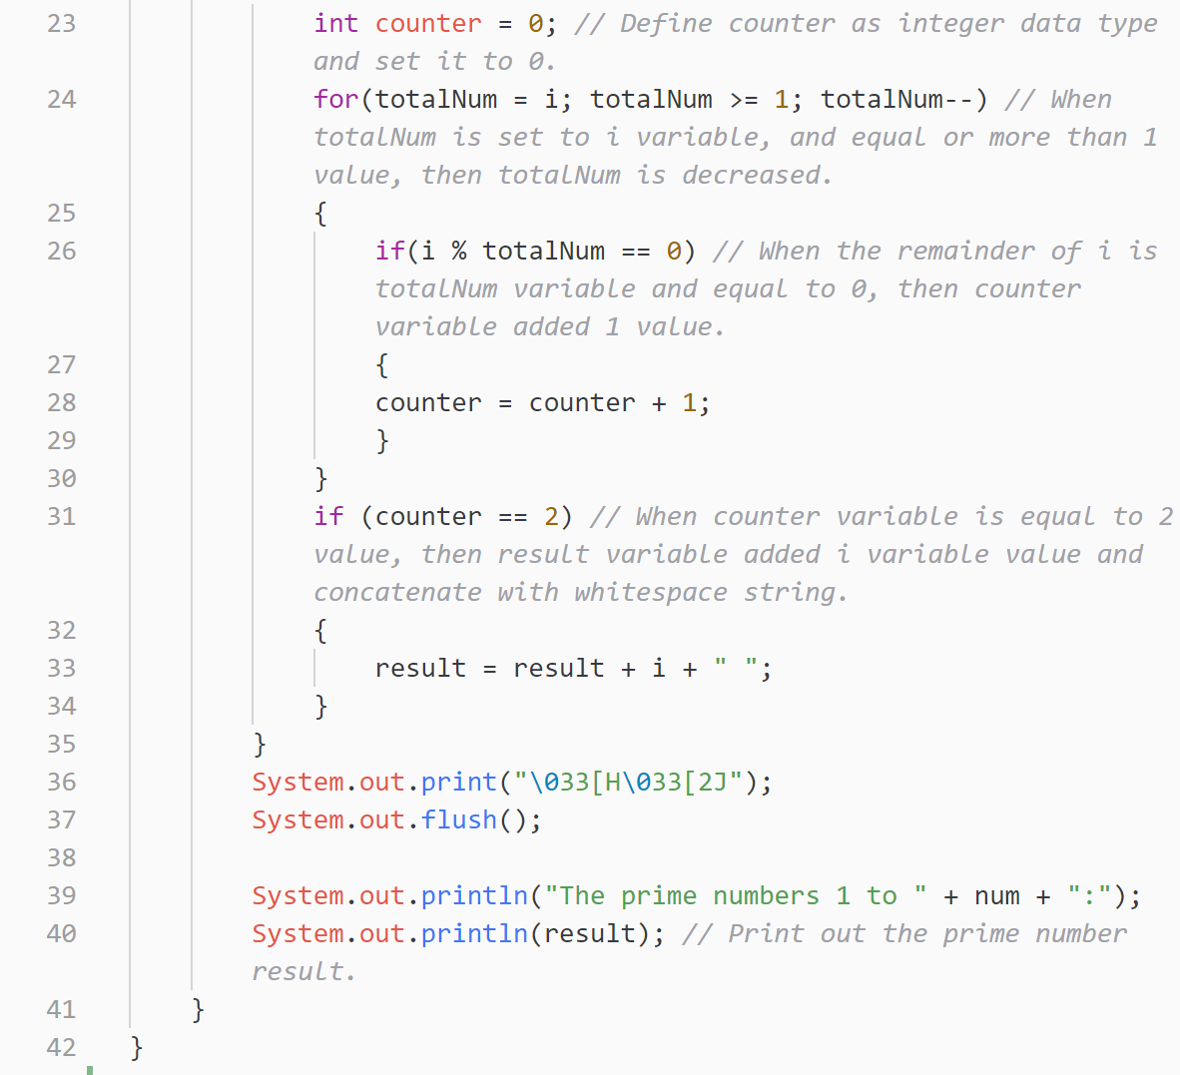

**Report: Assignment 1 (15%) – 75 marks Assignment 1 Rubric**

|  |  |  |  |  |  |
| --- | --- | --- | --- | --- | --- |
|  | **(1-3) Unsatisfactory** | **(4-7) Satisfactory** | **(8-11) Good** | **(12-15) Excellent** | **SCORE** |
| **Delivery** | * Completed less than 70% of the requirements. * Not delivered on time or 100% plagiarism | * Completed between 70-80% of the requirements. * Delivered on time, and 50% plagiarism | * Completed between 80-90% of the requirements. * Delivered on time, and no plagiarism | * Completed between 90-100% of the requirements. * Delivered on time, and no plagiarism |  |
| **Coding Standards** | * No name, date, or assignment title included * Poor use of white space * Disorganized and messy * Poor use of variables | * Includes name, date, and assignment title. * White space makes program fairly easy to read. * Organized work. * Good use of variables | * Includes name, date, and assignment title. * Good use of white space. * Organized work. * Good use of variables | * Includes name, date, and assignment title. * Excellent use of white space. * Creatively organized work. * Excellent use of variables |  |
| **Documentation** | * No documentation included. | * Basic documentation has been completed including descriptions of all variables. * Purpose is noted for each function. | * Clearly documented including descriptions of all variables. * Specific purpose is noted for each function and control structure. | * Clearly and effectively documented including descriptions of all variables. * Specific purpose is noted for each function, control structure, input requirements, and output results. |  |
| **Runtime** | * Does not execute due to errors. * User prompts are misleading or non-existent. * No testing has been completed. | * Executes without errors. * User prompts contain little information, poor design. * Some testing has been completed. | * Executes without errors. * User prompts are understandable, minimum use of symbols or spacing in output. * Thorough testing has been completed | * Executes without errors excellent user prompts, good use of symbols, spacing in output. * Thorough and organized testing has been completed and output from test cases is included. |  |
| **Efficiency** | * No solution | * A difficult and inefficient solution. | * A logical solution that is easy to follow but it is not the most efficient. | * Solution is efficient and easy to follow (i.e. no confusing tricks). |  |
| **TOTAL** |  |  |  |  | **/75** |

**Presentation: Assignment 1 (5%) – 25 marks**

|  |  |  |  |  |
| --- | --- | --- | --- | --- |
| **Performance Area** | **4-5: Exceeds Standards** | **2-3: Meets Standards** | **1: Fails to Meet Standards** | **Score** |
| **Organization** | Presenter follows logical sequence and provides explanations/elaboration. | Presenter follows logical sequence but fails to elaborate. | Presenter does not follow logical sequence (jumps around in presentation). | 5 4 3 2 1 |
| **Eye Contact** | Presenter seldom returns to notes, maintaining eye contact with audience throughout the presentation. | Presenter maintains eye contact with audience most of the time, but frequently returns to notes. | Presenter reads most or all of report, making little to no eye contact with audience. | 5 4 3 2 1 |
| **Delivery** | Presenter speaks clearly and loud enough for all in audience to hear, makes no grammatical errors, and pronounces all terms correctly and precisely. | Presenter’s voice is relatively clear, but too low to be heard by those in the back of the room. Presenter makes several major grammatical errors and mispronounces some terms. | Presenter mumbles, mispronounces terms, and makes serious and persistent grammatical errors throughout presentation. Presenter speaks too quietly to be heard by many in audience. | 5 4 3 2 1 |
| **Responsiveness:**  Q&A | Addresses all questions in a manner that demonstrates a thorough command of the topic(s) of the presentation. | Presenter demonstrates an ability to address most questions in a thoughtful and effective manner. | Presenter cannot address basic questions about the topic or addresses them in a superficial manner. | 5 4 3 2 1 |
| **Time** | Speaker uses the allotted time effectively. Finishes on time. | Speaker finishes on time but has to rush through last points to finish on time. | Speaker does not finish on time or finishes well before allotted time. | 5 4 3 2 1 |
|  | **TOTAL** | | | **/25** |

**Presentation: Assignment 1 (5%) – 25 marks**

|  |  |  |  |  |
| --- | --- | --- | --- | --- |
| **Performance Area** | **4-5: Exceeds Standards** | **2-3: Meets Standards** | **1: Fails to Meet Standards** | **Score** |
| **Organization** | Presenter follows logical sequence and provides explanations/elaboration. | Presenter follows logical sequence but fails to elaborate. | Presenter does not follow logical sequence (jumps around in presentation). | 5 4 3 2 1 |
| **Eye Contact** | Presenter seldom returns to notes, maintaining eye contact with audience throughout the presentation. | Presenter maintains eye contact with audience most of the time, but frequently returns to notes. | Presenter reads most or all of report, making little to no eye contact with audience. | 5 4 3 2 1 |
| **Delivery** | Presenter speaks clearly and loud enough for all in audience to hear, makes no grammatical errors, and pronounces all terms correctly and precisely. | Presenter’s voice is relatively clear, but too low to be heard by those in the back of the room. Presenter makes several major grammatical errors and mispronounces some terms. | Presenter mumbles, mispronounces terms, and makes serious and persistent grammatical errors throughout presentation. Presenter speaks too quietly to be heard by many in audience. | 5 4 3 2 1 |
| **Responsiveness:**  Q&A | Addresses all questions in a manner that demonstrates a thorough command of the topic(s) of the presentation. | Presenter demonstrates an ability to address most questions in a thoughtful and effective manner. | Presenter cannot address basic questions about the topic or addresses them in a superficial manner. | 5 4 3 2 1 |
| **Time** | Speaker uses the allotted time effectively. Finishes on time. | Speaker finishes on time but has to rush through last points to finish on time. | Speaker does not finish on time or finishes well before allotted time. | 5 4 3 2 1 |
|  | **TOTAL** | | | **/25** |

**Presentation: Assignment 1 (5%) – 25 marks**

|  |  |  |  |  |
| --- | --- | --- | --- | --- |
| **Performance Area** | **4-5: Exceeds Standards** | **2-3: Meets Standards** | **1: Fails to Meet Standards** | **Score** |
| **Organization** | Presenter follows logical sequence and provides explanations/elaboration. | Presenter follows logical sequence but fails to elaborate. | Presenter does not follow logical sequence (jumps around in presentation). | 5 4 3 2 1 |
| **Eye Contact** | Presenter seldom returns to notes, maintaining eye contact with audience throughout the presentation. | Presenter maintains eye contact with audience most of the time, but frequently returns to notes. | Presenter reads most or all of report, making little to no eye contact with audience. | 5 4 3 2 1 |
| **Delivery** | Presenter speaks clearly and loud enough for all in audience to hear, makes no grammatical errors, and pronounces all terms correctly and precisely. | Presenter’s voice is relatively clear, but too low to be heard by those in the back of the room. Presenter makes several major grammatical errors and mispronounces some terms. | Presenter mumbles, mispronounces terms, and makes serious and persistent grammatical errors throughout presentation. Presenter speaks too quietly to be heard by many in audience. | 5 4 3 2 1 |
| **Responsiveness:**  Q&A | Addresses all questions in a manner that demonstrates a thorough command of the topic(s) of the presentation. | Presenter demonstrates an ability to address most questions in a thoughtful and effective manner. | Presenter cannot address basic questions about the topic or addresses them in a superficial manner. | 5 4 3 2 1 |
| **Time** | Speaker uses the allotted time effectively. Finishes on time. | Speaker finishes on time but has to rush through last points to finish on time. | Speaker does not finish on time or finishes well before allotted time. | 5 4 3 2 1 |
|  | **TOTAL** | | | **/25** |